Help Spread the Word
Ohio School Breakfast Challenge:
Social Media Messages
for Stakeholders
- Share messages through e-newsletters, social media and website content
- Join the conversation on Twitter using the hashtag #OHSBC
- Join the conversation on Facebook by liking and sharing posts about the Ohio School Breakfast Challenge, and post on your organization’s Facebook page

Twitter and Facebook Teasers
Join in the School Breakfast Movement! Find helpful tools and #OHSBC resources at www.OhioSchoolBreakfastChallenge.com
Celebrate the #OHSBC Breakfast All-Star Schools for their outstanding efforts to increase school breakfast participation. See the winners >> https://www.ohioschoolbreakfastchallenge.com/wp-content/uploads/2018/05/Breakfast-All-STAR-2018-FINAL-Group.pdf
329 schools met the criteria for the Ohio School Breakfast Challenge and will receive an All-Star Breakfast Banner at the Ohio School Board Association, Capital Conference! See the list of winners >> https://www.ohioschoolbreakfastchallenge.com/wp-content/uploads/2018/05/Breakfast-All-STAR-2018-FINAL-Group.pdf
On average, students who eat school breakfast attend 1.5 more days of school per year and score 17.5% higher on standardized math tests. #OHSBC http://www.ohioschoolbreakfastchallenge.com/about/
Studies show that grades and attendance rise when breakfast is served during the school day. #OHSBC http://www.ohioschoolbreakfastchallenge.com/about/
It’s a fact: Students that eat school breakfast are more attentive in the classroom, have better behavior, math grades and standardized test scores. #OHSBC http://www.ohioschoolbreakfastchallenge.com/about/
DYK: Students who eat school breakfast have better nutrition. #OHSBC http://www.ohioschoolbreakfastchallenge.com/about/
School breakfast helps students do their best! Take the Ohio School Breakfast Challenge. #OHSBC
Breakfast is considered the most important meal of the day because it refuels the body and brain with energy to start the day. Learn about the Ohio School Breakfast Challenge! http://www.ohioschoolbreakfastchallenge.com/about/

Eating school breakfast together in the classroom creates a feeling of community. All students get a healthy start to do their best with the #OHSBC! http://www.ohioschoolbreakfastchallenge.com/about/
The Ohio School Breakfast Challenge encourages all schools to give students a healthy start to do their best. http://www.ohioschoolbreakfastchallenge.com/about/
Only 35.3 percent of teens report eating breakfast every day. The Ohio School Breakfast Challenge I working to change that. Learn how >> http://www.ohioschoolbreakfastchallenge.com/about/
The Ohio School Breakfast Challenge Is Back! Join the movement - participate in the Spring 2019 Challenge! http://www.ohioschoolbreakfastchallenge.com/about/
Participate in the Ohio School Breakfast Challenge to be recognized for your #breakfast efforts! http://www.ohioschoolbreakfastchallenge.com/about/
Looking for ways to increase your school’s #breakfast participation? Find helpful tools and resources here >> http://www.ohioschoolbreakfastchallenge.com/resources/
Is your school a Breakfast All-Star? Participate in the #OHSBC to earn the recognition for your school! Learn how >> http://www.ohioschoolbreakfastchallenge.com/
Newsletter Sample:
Celebrate the 2018 Ohio School Breakfast Challenge Award Winners
Congratulations to the 2018 Ohio School Breakfast Challenge schools for their outstanding efforts to increase school breakfast participation! In Ohio, 329 schools met the criteria of the Ohio School Breakfast Challenge and are recognized as Breakfast All-Star Schools. Click here to see the complete list of Breakfast All-Star Schools.
The Ohio School Breakfast Challenge Is Back for Spring 2019!
The Ohio School Breakfast Challenge encourages all schools to give their students a great start to their day with a healthy breakfast. Why? Breakfast helps students do their best. All schools offering the School Breakfast Program can participate in the Challenge by submitting their breakfast participation data from February 1, 2019 thru March 29, 2019. Find helpful tools and resources to get started at www.OhioSchoolBreakfastChallenge.com
Social media images are available for download at:
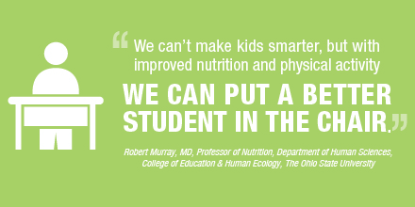
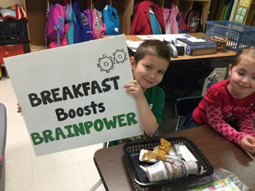
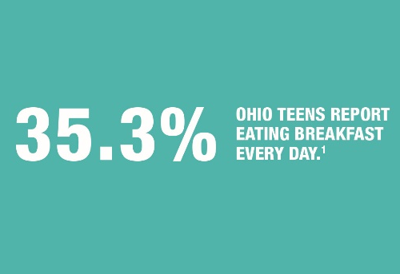
https://www.dropbox.com/sh/edb1tt9k8f9wypl/AAA4uxMPhV5GkRdQ2yOVdBNJa?dl=0

