Social Media Messages
for Schools
Ohio School Breakfast Challenge:

Help Spread the Word
- Share breakfast messages through e-newsletters, social media and other school announcements
- Join the conversation on Twitter using the hashtags #OHSBC and #Breakfast
- Like and share posts on your Facebook page

Twitter and Facebook Teasers
DYK: School breakfast is a great way to kickstart your student's day when you're crunched for time in the AM #OHSBC http://bit.ly/OHSBC

Give ‘Em Breakfast. Give ‘Em A Boost. Does your school offer #breakfast in the morning? If not, encourage them to >> http://bit.ly/OHSBC

#Breakfast is the most important meal of the day because it refuels the body and the brain. Get the facts >> http://bit.ly/2fENo37

Moms & Dads know best - a healthy #breakfast helps kids to do their best! #OHSBC http://bit.ly/OHSBC

If your kids aren’t hungry first thing in the morning, have them eat breakfast at school! Studies show breakfast fuels their brains and bodies. #OHSBC http://bit.ly/OHSBC

#Breakfast - it’s smart! Help your kids get the best start to their day! http://bit.ly/1pLyozr

Breakfast fills your child's "empty tank" to get them going after a long night of sleeping. #OHSBC http://bit.ly/OHSBC

Why is #breakfast the most important meal of the day? It provides fuel and boosts brainpower! http://bit.ly/1N8TNrA

Build a better #breakfast by including at least 3 of the 5 food groups. What’s your favorite combo? http://bit.ly/2x2ccog

Parent Power! Be a role model & make sure your kids see you eating #breakfast. Better yet, eat breakfast together! http://bit.ly/1N8TywN
Make sure your family fuels up with a healthy breakfast every day. Learn why it’s important >> http://bit.ly/OHSBC

Kids who skip breakfast often mistake hunger pangs for a tummy ache. Eat breakfast at school to fight hunger #OHSBC http://bit.ly/OHSBC

Breakfast Builds Brain Power! Studies link the importance of breakfast and children's performance in school >> http://bit.ly/OHSBC

Breakfast provides kids the get-up-and-go they need to listen and learn in school. >> http://bit.ly/OHSBC

DYK: Students can get a healthy breakfast at school complete with whole grains, fruit and dairy!

School breakfast provides a simple and healthy option for families every morning. Tomorrow we’re having [insert menu item and share a photo]

A healthy school breakfast like [insert menu item and share a photo] helps students perform their best in the classroom! #OHSBC

All students are welcome to join us for breakfast so they can start the day ready to learn. The cafeteria opens at [insert service start time]. #OHSBC

My name is Mr./Mrs. __and I teach grade. My favorite school breakfast is [insert menu item and share a photo with teacher & item] which is on the menu tomorrow at [insert service start time]. #OHSBC

Newsletter Sample:
[School] Named an Ohio Breakfast All-Star School
[School Name] took the Ohio School Breakfast Challenge and was named a Breakfast All-Star School for their outstanding efforts in increasing school breakfast participation! In Ohio, 329 schools met the criteria of the Ohio School Breakfast Challenge and are recognized as Breakfast All-Star Schools. Click here to see the complete list of Breakfast All-Star Schools.
Social media images are available for download at:
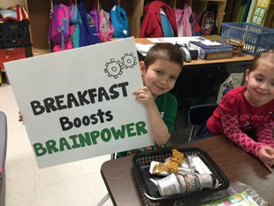
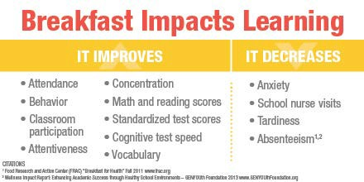
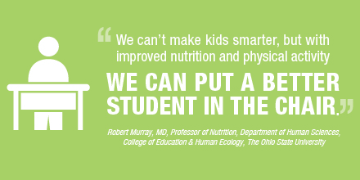
https://www.dropbox.com/sh/edb1tt9k8f9wypl/AAA4uxMPhV5GkRdQ2yOVdBNJa?dl=0

